**21K-3278-D**

**Sohaib Sarosh Shamsi**

Q1.

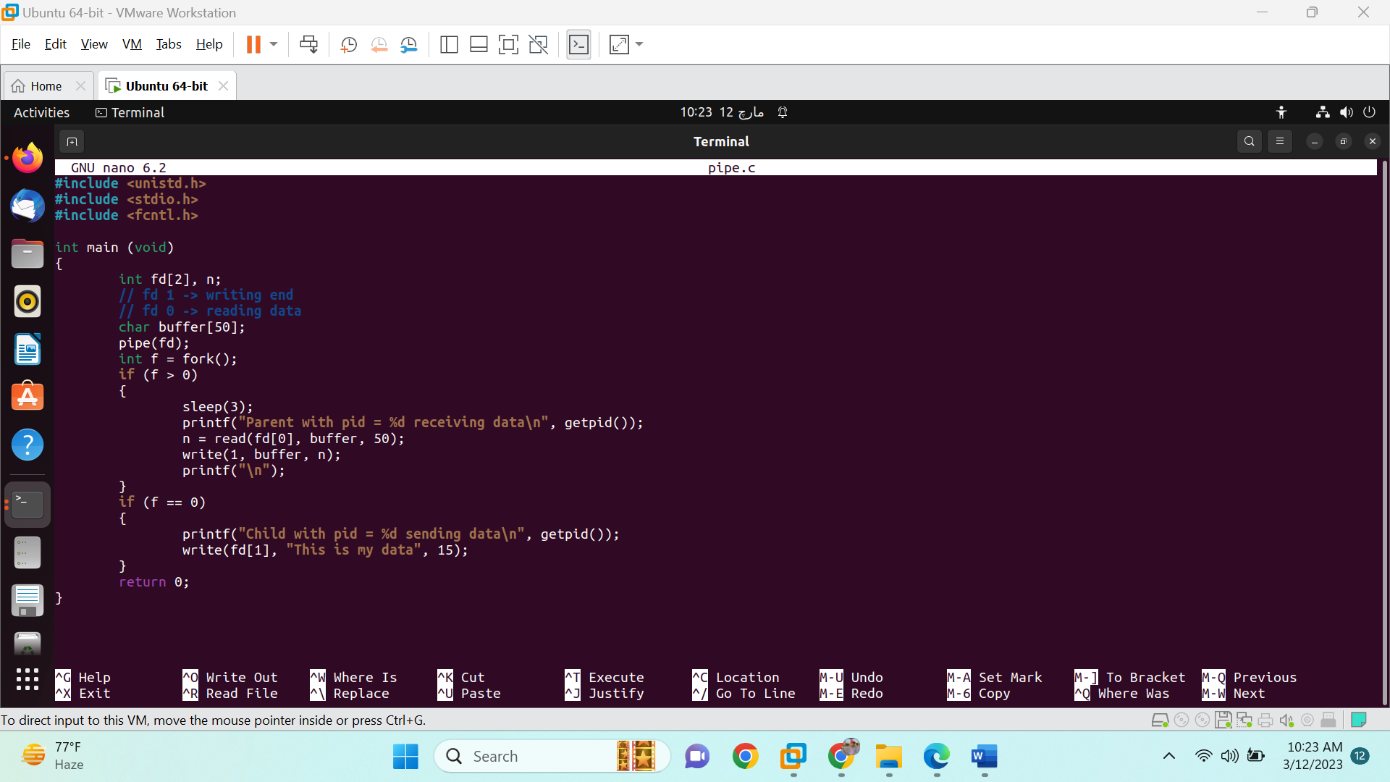

Q2.

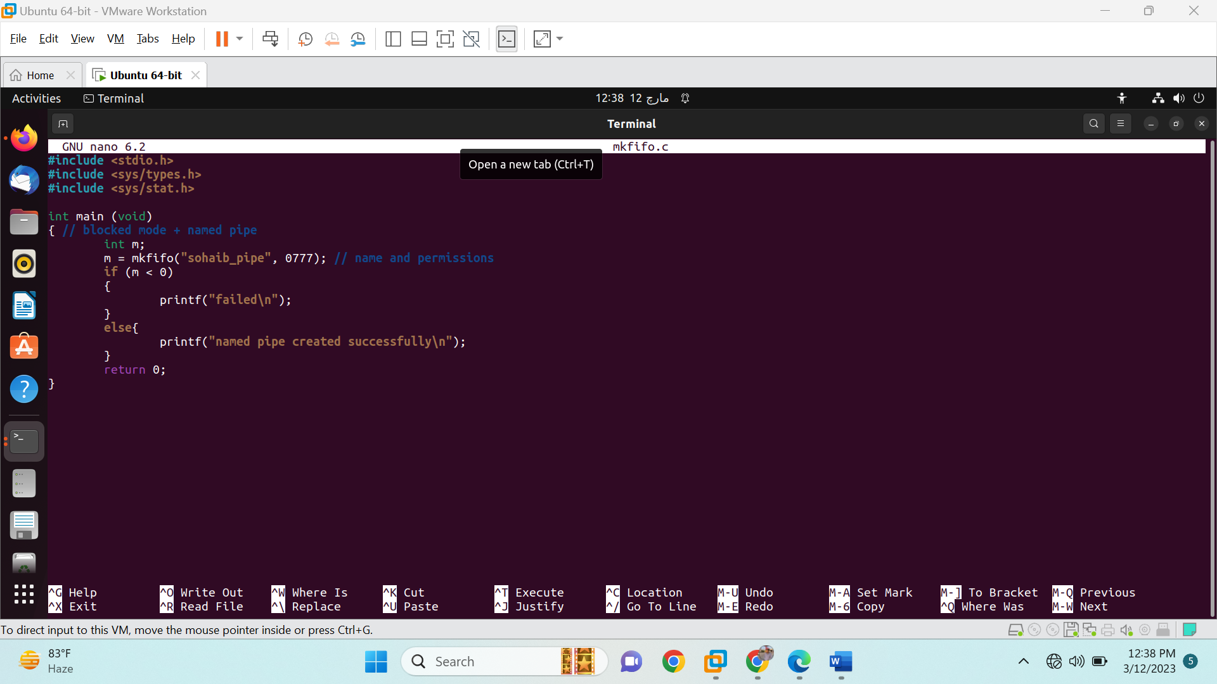

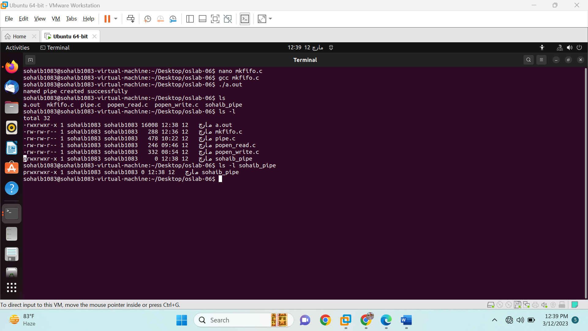

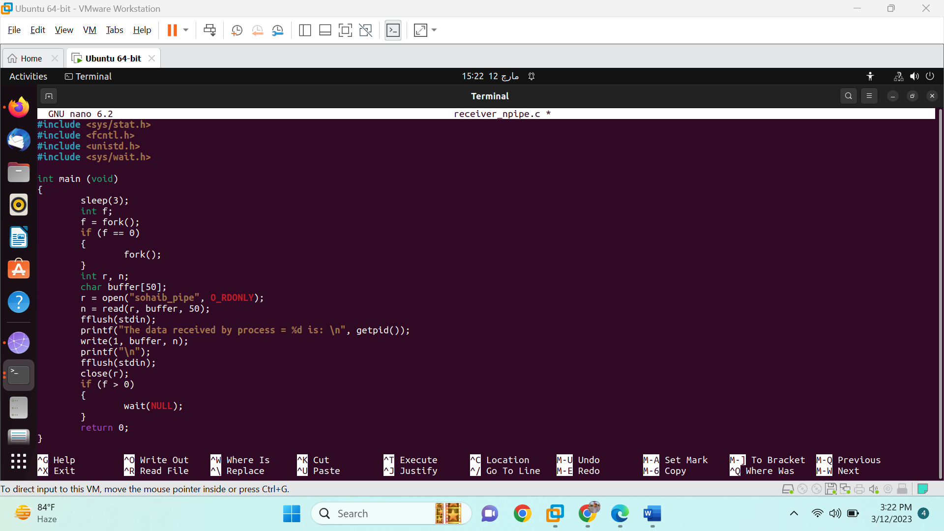

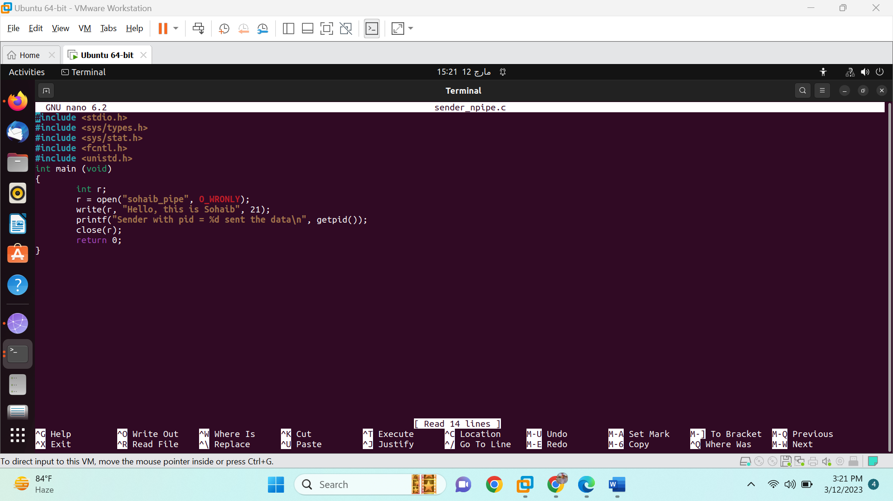

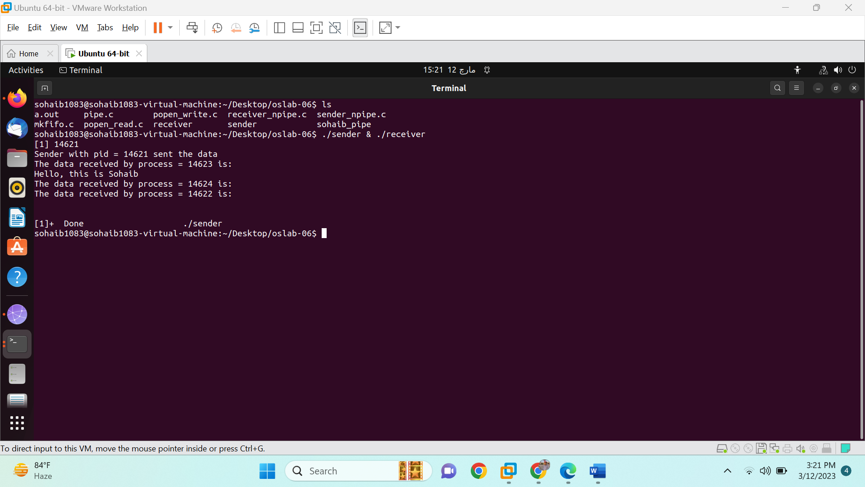

Q3.

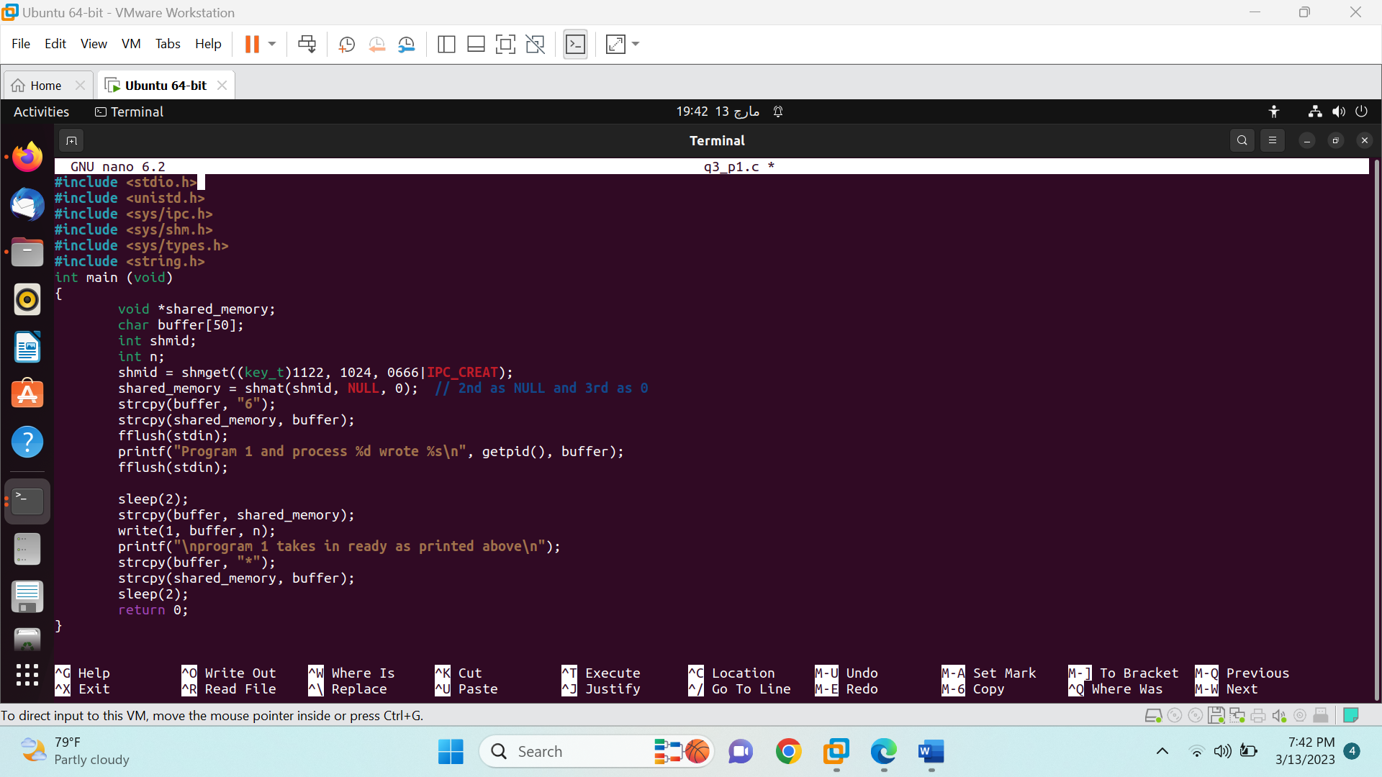

Q4.



